Digital Data Communications Message Protocol (DDCMP)

1. Byte orşented communication protocol
2. Devised by Digital Equipment Corporation
3. It is a byte counting approach.
4. Count field in the frame format
5. Count: How many bytes are contained in the frame body?

Frame format:

1. 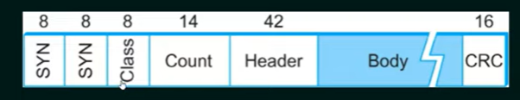

Danger with the count field

One danger with this approach is that if transmission error could corrupt the count field then the end of the frame would not be correctly detected by the receiver.